The Robbins Juried Art Exhibit: A Showcase of Local Visual Art
Exhibition Opening May, 2013
The annual juried art exhibit in the beautiful Warsaw Performing Art Center Gallery in Warsaw, Indiana, will run the month of May. Submissions are due April 5th. The show judging will be directed by artist and instructor emeritus Sara Robbins. Artist must be willing to drop off the artwork at the WCHS: Performing Art Center and pick it up.

INFORMATION & INSTRUCTIONS
1 | No Entry Fee
2 | Entries will be judged via digital imaging. Artist will submit 2 jpeg images in any category such as sculpture, painting, photography, graphic design, crafts, and printmaking via email or CD. (Video entries will not be accepted. Entries must be able to be displayed if accepted).  Email:dswartzentruber@warsaw.k12.in.us  Address: Warsaw Performing Art Center, c/o D.M. Swartzentruber, 1 Tiger Lane, Warsaw, IN 46580  Entry email or CD must arrive by April 5th.
3 | ARTWORK SPECIFICATIONS: All work must be original. No copies or work done from commercially prepared kits or molds will be accepted. If outside sources are used, it must be altered so it is unrecognizable. Maximum size not to exceed 4 feet in height and 1 foot in depth. Maximum weight not to exceed 45 lbs. No entry of a fragile nature should be entered, such as unfired ceramic or plaster.
4 | JPEG SPECIFICATIONS: Each jpeg (300 KB or smaller) must be labeled with the artist’s name and all additional information (title, dimensions of work, medium) is to be included within the detail tab of Properties. The jpegs and entry form can be submitted digitally through e-mail, or the images can be on a CD with a printed copy of the entry form mailed to the school (address and email included above).
 | ACCEPTED ENTRIES: CD’s that are not accepted for the show will be returned by mail if you include a stamped self-addressed envelope; all other CDs will not be returned. Accepted entries will be notified by Monday, April 15th, and if you are mailing your accepted work it needs to be received by Monday, April 22nd or April 23rd, 2013.
 | All accepted entries must be framed or matted and equipped for exhibiting and handling. No frames with exposed glass edges will be accepted. All framed art must be ready for display with a picture wire.
 | SALES: The PAC does not sell artwork or take any commission. Sales are to be handled between artist and patron.
 | LIABILITY: Although every precaution will be taken to protect all art on display, WCHS will assume no responsibility for loss due to fire, weather, theft, or damage which might be sustained. We also disclaim responsibility for any entry not claimed one month after the end of the exhibition.

PICKUP ARTWORK: Work that has been exhibited must be reclaimed after the show.
Pickup is Monday June 3rd and Tuesday the 4th , between 3:00 and 5:00.

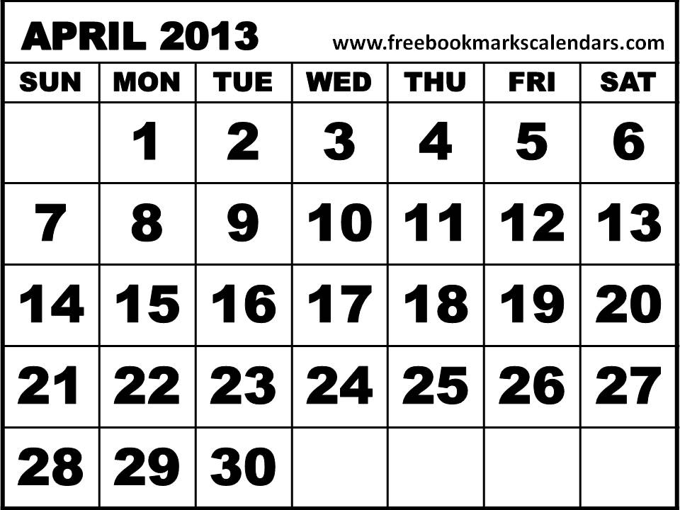
APRIL 5th: ENTRIES DUE
APRIL 15th: NOTIFICATION
APRIL 8th-12th: JUDGING

APRIL 22nd-23rd: DROP OFF OF ACCEPTED ENTRIES

FOR ACCEPTED WORK:
Please attach this information slip to the back of each accepted artwork.
……………………………………………………………………………………………………………………
Warsaw Performing Art Center Juried Exhibition
Name_________________________________________________________________________
Address_______________________________________________________________________
City_________________________________________State_________Zip_________________
Telephone_______________________Email________________________________________
Title__________________________________________________________________________
Price: $_____________Medium___________________________ Size__________________
………………………………………………………………………………………………………….
Warsaw Performing Art Center Juried Exhibition
Name_________________________________________________________________________
Address_______________________________________________________________________
City_________________________________________State_________Zip_________________
Telephone_______________________Email________________________________________
Title__________________________________________________________________________
Price: $_____________Medium___________________________ Size__________________

